James E. Wallace (Jim), 85 of Cambridge, Massachusetts, passed away on July 31, 2021 at his Houston residence, following a battle with an aggressive form of prostate cancer.
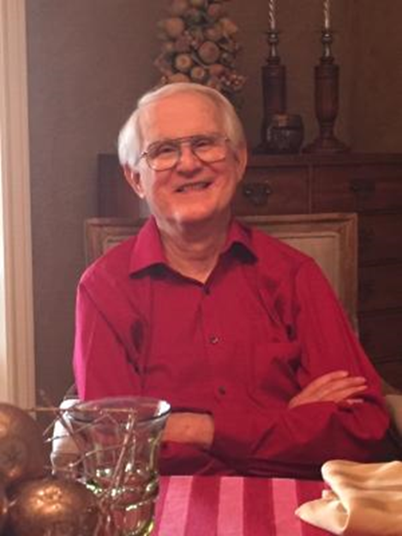
Born September 8, 1935 in Reidsville, North Carolina, son of the late Earl Francis Wallace and Virginia Morton Wallace. Jim was predeceased by his beloved wife Julia Abernethy Wallace. He is survived by his wife Renee Seale of Houston, Texas, his daughter Ginny Greene and her husband Brian Greene of Cambridge, MA and son Walter Wallace and his wife Eunju Lee of Brooklyn, N.Y. He is also survived by grandchildren James Jin Wallace-Lee and Sara Ryong Wallace-Lee of Brooklyn N.Y., and brothers, Robert Wallace of Fort Worth, TX, and his wife Carolynn, Richard Wallace of Denver, CO, and Paul Wallace of Altadena, CA and his wife Judy.

Jim was a “ray of sunshine”, known for his optimistic outlook and kind, gregarious manner. Jim “never met a stranger”. He had a way of making everyone feel special, quickly connecting with people and establishing lasting relationships. Jim was a father figure and mentor to many. He had a keen intellect and was a hard worker with an ability to keep his “nose to the grindstone” until he got a task done. He was a natural leader who applied the courage of his convictions to make the world a better place.

Though Jim’s mother tried to convince him to become a missionary or minister, he found the courage to be true to himself and earned a BS degree in Mechanical Engineering from North Carolina State University in Raleigh NC. Jim married his college sweetheart, Julia Abernethy, and moved to Ithaca, NY where he earned a Masters degree in Aeronautical Engineering from Cornell University. A rocket scientist, Jim served his country in the Air Force while stationed in Los Angeles, CA. Concerned about racism, he attended an African-American church and led the church’s youth group. Later he moved to Buffalo, NY where he worked as a rocket scientist at Cornell Lab. While in Buffalo, Jim volunteered with H.O.M.E, Housing Opportunities Made Equal. He recruited volunteers to expose illegal discrimination by realtors against African American families attempting to buy homes in good neighborhoods. That experience led Jim to re-focus his career on fair housing instead of rocket science. In 1968 Jim moved his family to Cambridge, MA where he studied Urban Planning, and earned a Ph.D from the Massachusetts Institute of Technology.

A passionate environmentalist, for several decades Jim rode his bike daily to his job at Abt Associates in Cambridge where he worked as a consultant and later a served as Vice President, focusing on Federal Housing and Urban Development contracts.

Along with his wife Julia, Jim worked tirelessly for peace and justice for over 40 years in Cambridge, MA. They helped sponsor a family from Chile that was fleeing from oppression. Jim and Julia and Old Cambridge Baptist Church led the effort for Cambridge to become a sanctuary city in 1985. Jim and Julia provided direct Sanctuary for several years to a woman and her family escaping the violence in El Salvador. Jim was a founder and heart and soul of the Cambridge El Salvador sister city project, a formal relationship established between the City of Cambridge, MA and the small community of San Jose Las Flores in 1987. For almost 35 years Jim was a leader in the solidarity movement.

Jim was a pillar of Old Cambridge Baptist Church where he served in almost every capacity. He spearheaded the founding of Common Place, an intentional living community that still thrives 47 years later.

Two of Jim’s greatest passions were family and music. The family spent wonderful time every summer at their cottage at Wellfleet on Cape Cod. Sara and James traveled with grandpa to England, Scotland, and Mexico. Jim found lifelong joy in music. Growing up he was the pianist for his home church. He sang bass in the OCBC choir, but jazz was his first love. He relished family jam sessions with his son, Walter, on bass and his grandson, James on piano.

Julia Wallace died in 2010 after a long battle with Lewy Body Dementia. Throughout her illness, Jim took care of her at home. In 2013 Jim married Renee Seale, a psychiatric social worker from Houston, TX. She retired from her private psychotherapy practice of 37 years when she moved to Cambridge to be with Jim. Together they embarked on an exciting new life together. Renee had lived in Cambridge in the 1970s, attended OCBC, and kept in close contact with people at Common Place and OCBC. To her, being at Common Place was like “coming home.” Jim quickly embraced Renee’s large, welcoming family in Houston, her church, Covenant and her little dog, Ellie. He became an avid fan of the Houston Livestock and Rodeo. Jim and Renee were lucky enough to spend the colder winter months in Houston and the rest of the year in Cambridge. They enjoyed entertaining visitors in both places, traveled to Europe with the OCBC choir, and followed their social Justice convictions together. Most recently, they volunteered with the Harvard Square church’s Sanctuary effort to support a refugee family.

Jim Wallace lived a full, productive life. He will be missed by so many. Memorial services will be announced at a later date. In lieu of flowers donations can be sent to Old Cambridge Baptist Church, 1151 Mass Ave. Cambridge, MA 02138 or Covenant Baptist Church 4949 Caroline St. Houston, TX 77004.

